# ASSIGNMENT-4

## DISTANCE DETECTION USING ULTRASONIC SENSOR

|  |  |
| --- | --- |
| Date | 23 October 2022 |
| Team ID | PNT2022TMID19437 |
| Name | Sanjay R |
| Student Roll Number | 722819104128 |
| Maximum Marks | 2 Marks |

QUESTION:

Write code and connections in wokwi for ultrasonic sensor. Whenever distance is less than 100 cms send "alert" to ibm cloud and display in device recent events.

CODE:

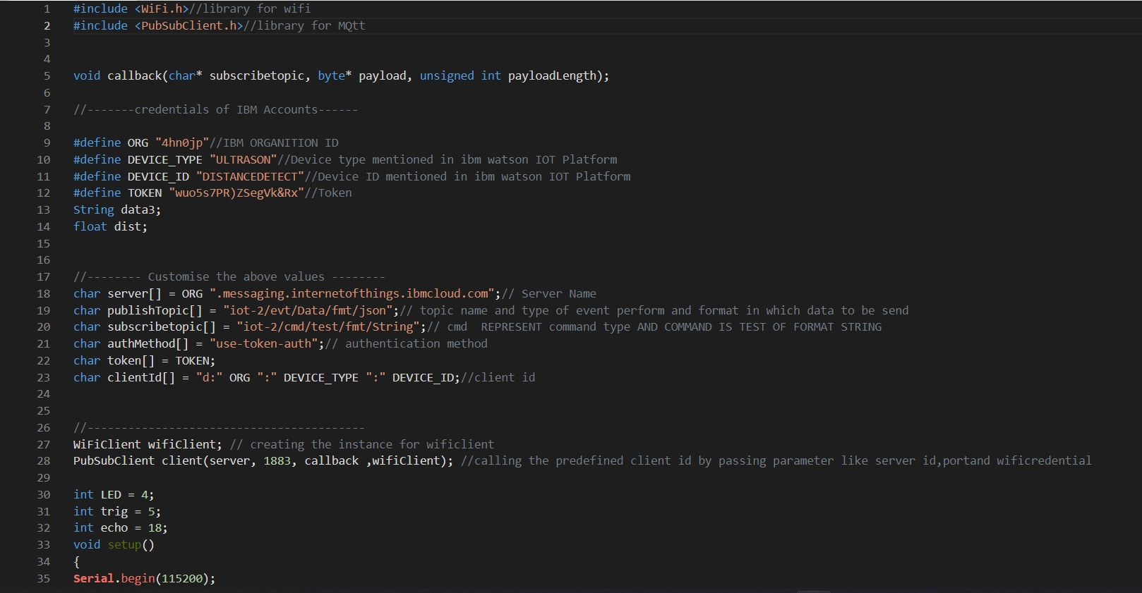

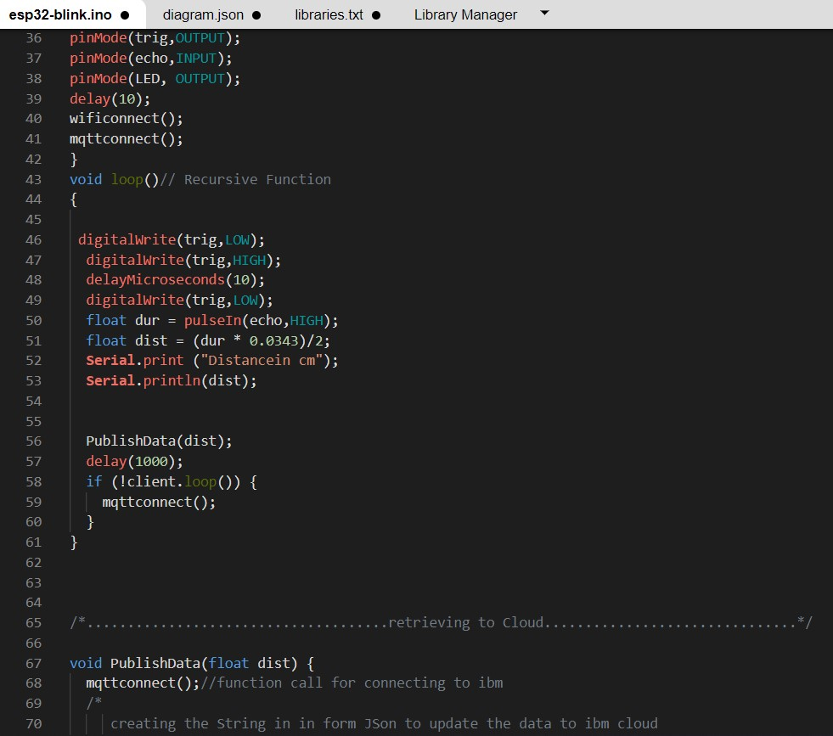

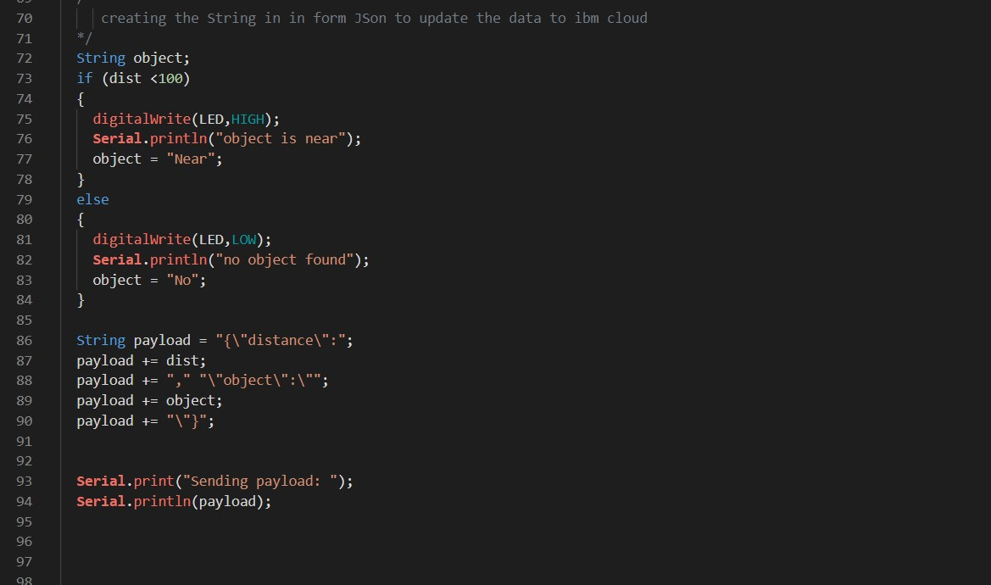

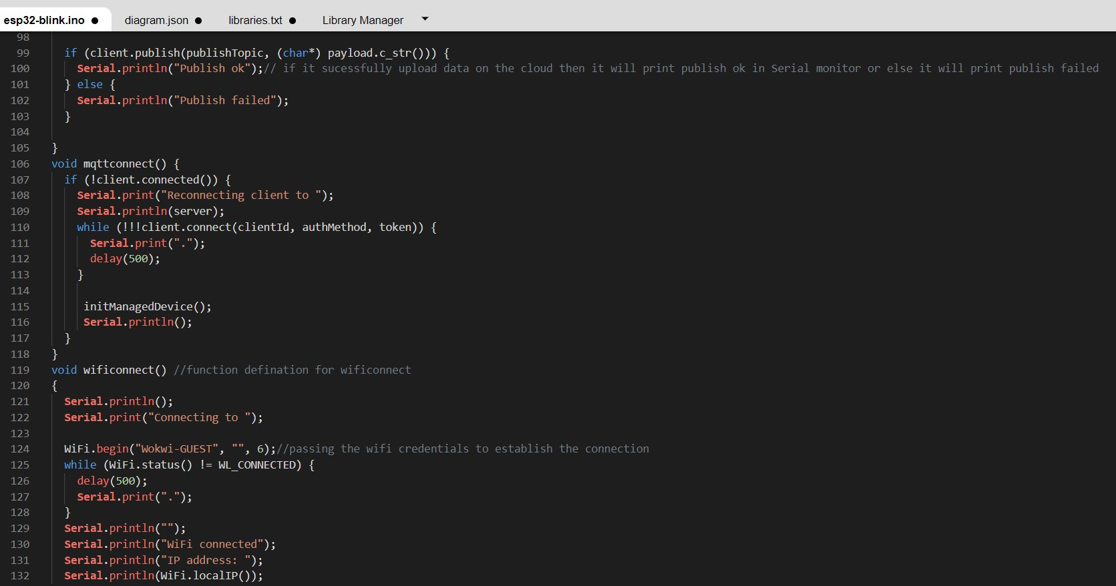

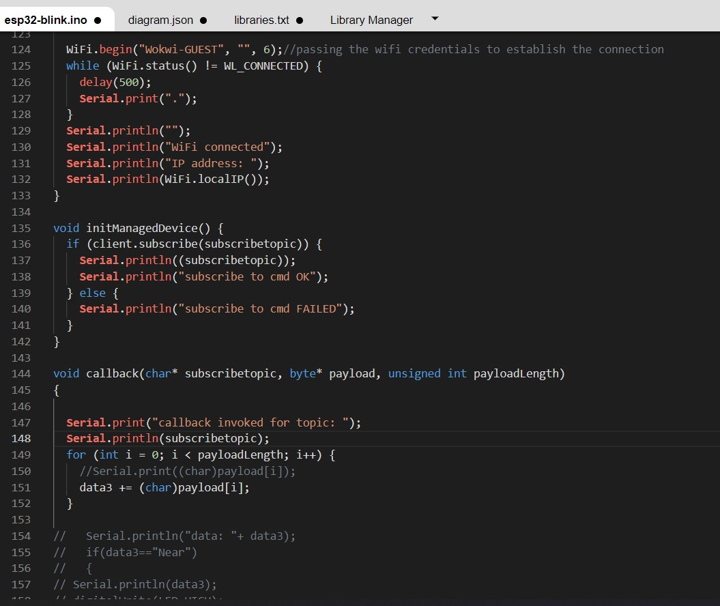

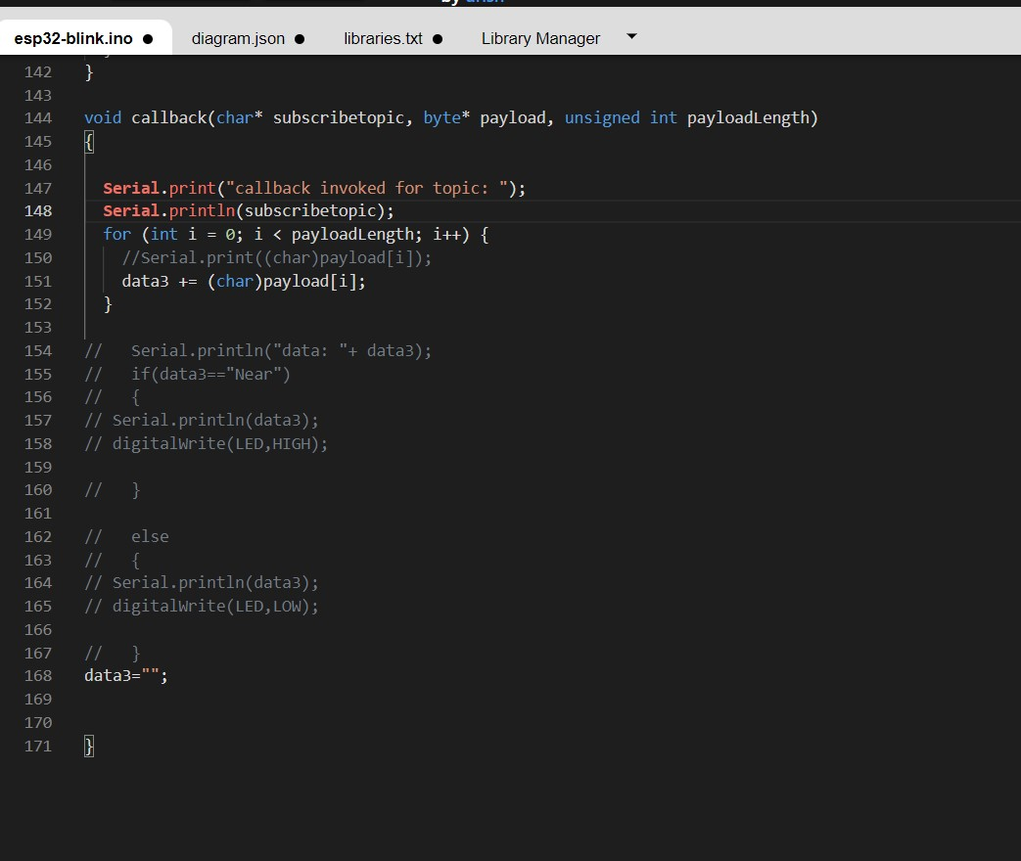

OUTPUT:

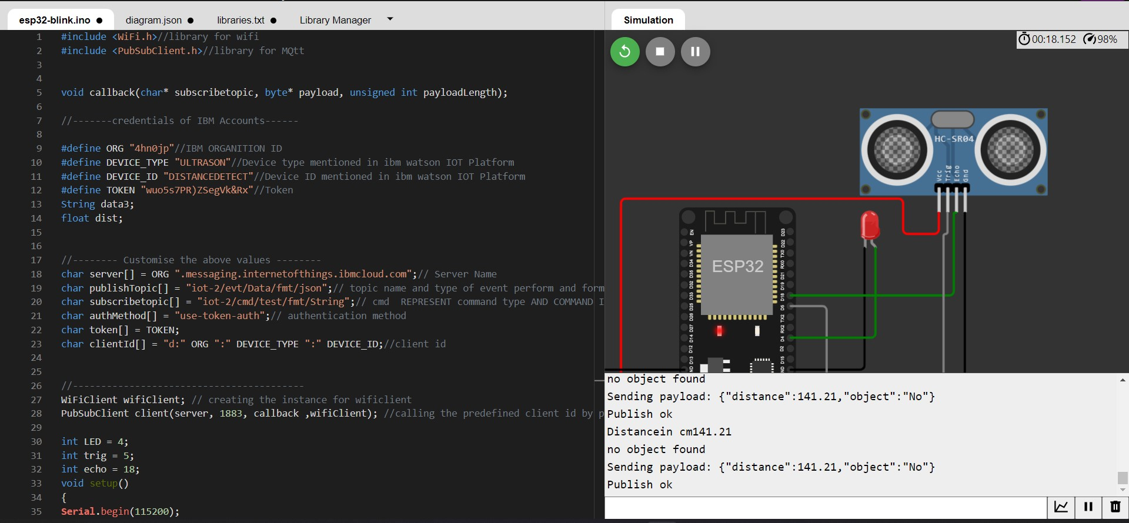

# Data send to the IBM cloud device when the object is far

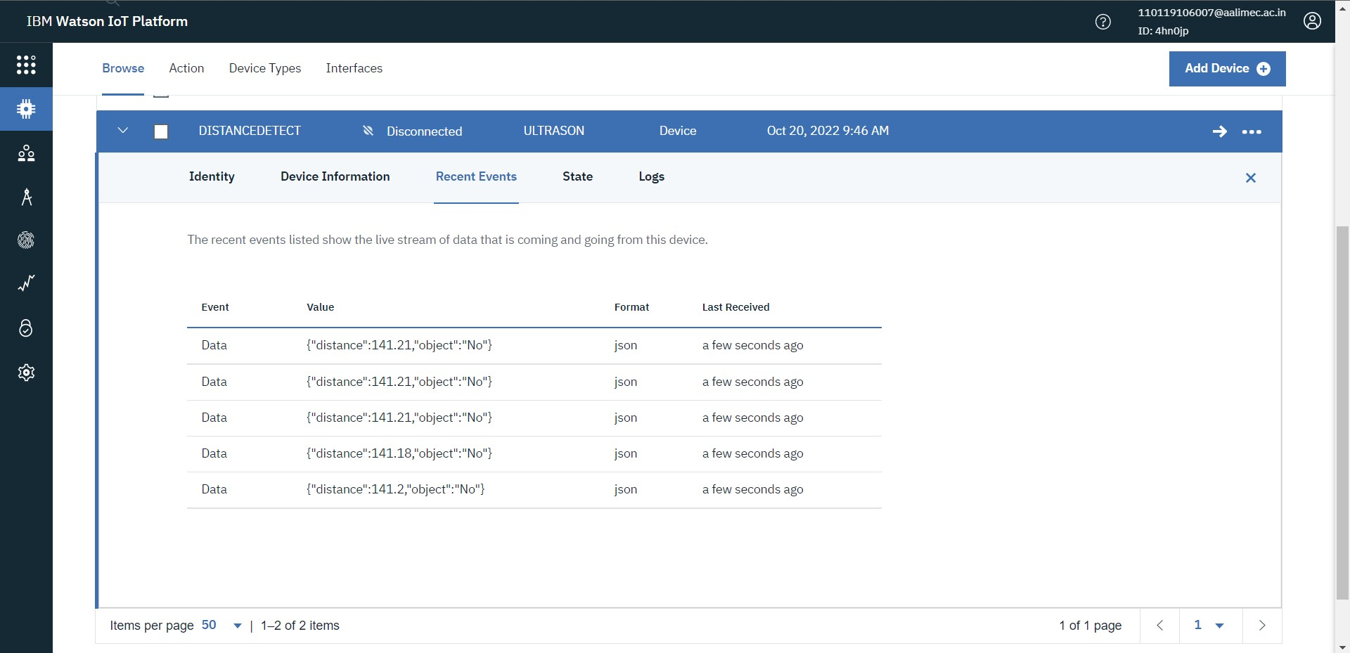

# when object is near to the ultrasonic sensor

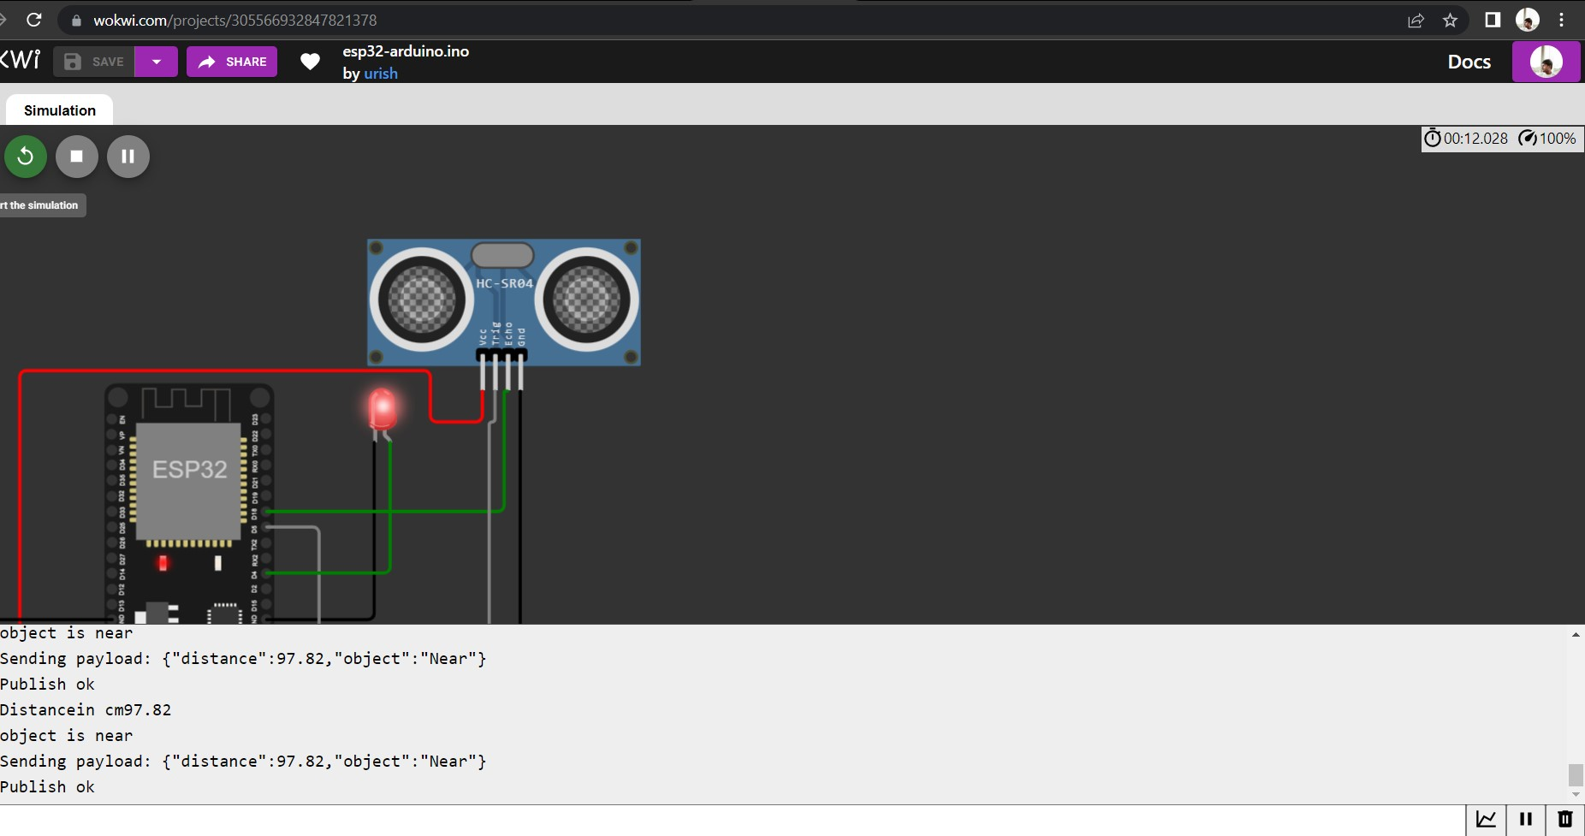

# Data sent to the IBM Cloud Device when the object is near

